Precious Pet Cremation
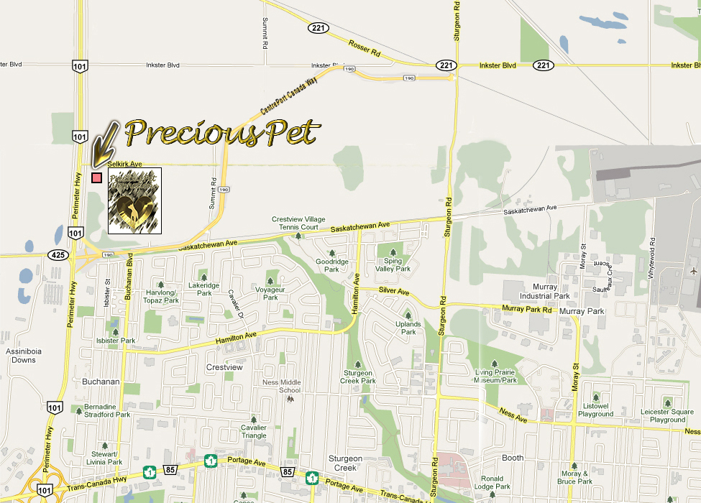

We are located directly off Perimeter Hwy 101 North - at the junction of the Perimeter Hwy and Selkirk Road.
There is a break in the meridian at the junction of Perimeter 101 North and Selkirk Road.
Turn off the Perimeter Hwy onto Selkirk Road and we are the big blue and white brick building you will see as soon as you turn onto Selkirk Road.

